Skip to the: Main Content.



COPYRIGHT RESERVED.
This article appeared in the Summer 1973 (Issue #32) edition of the Kent Archaeological Review.
Permission should be sought from the Honorary editor (in writing) to reproduce or quote from articles in the K A R.
The CKA and the Honorary Editor are not responsible for opinions and statements expressed by contributors to the K A R.
Please also note.

The Iron Age Hill-Forts at Castle Hill, Capel, near Tonbridge.
by J H Money, FSA.
In the summers of 1969, 1970 and 1971 I directed excavations in the two Iron Age hill-forts at Castle Hill. Some work was done there in 1929 by the late S E Winbolt, who considered that there was only one fort and produced a fanciful plan of it. See Footnote [1] A study of air photographs, however, shows Two forts with defences intact in the woodland but ploughed down where they cross the arable field on top of the hill.
The work was carried out by kind permission of Sir Henry d'Avigdor-Goldsmid and Mr James Hill. It was financed by the Kent Archaeological Society, the Tonbridge Urban and Rural District Councils, the Tonbridge Historical Society and a number of private contributors. Diggers included members of the Archaeological Group of the THS.
Castle Hill, which is on a spur of high ground running from North-East to South-West dominated the natural North-West to South-East route which the A21 follows today and exercised indirect control over the river crossing at Tonbridge, which has always been a vital point on a much used north-south route across the Weald.
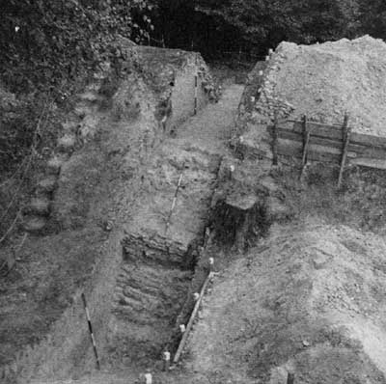
Photo Caption: Figure 1: The completed section of Fort I, showing rock-cut ditch and outer rampart, looking north.
Radiocarbon dates have been given by the British Museum for charcoals collected from the top of the old land surface under the outer rampart of Fort I, which lies at the North-East end of the spur, and the inner rampart of Fort II, which lies to the South-West. That from Fort I was dated to about 315 BC and Fort II about 228 BC. This suggestion that Fort I is the earlier is supported by the presence of tumbled revetting stones and burnt timbers in the ditch silt beside the entrance. Whether this destruction was deliberate or accidental, it can reasonably be argued that the local inhabitants, when faced with the need to construct another fort, abandoned the old site, chose the only remaining position suitable for defence and built new but rather weaker fortifications enclosing a slightly smaller area.
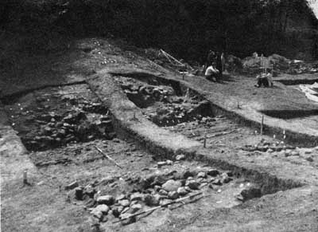
Photo Caption: Figure 2: The east entrance of Fort I with stone revetments and metalled road, looking south.
Who were these people? Farmers, and peasants probably, who built the forts as refuges against actual or potential threats. They made plentiful use of oak for palisades and revetting fences, and these could have kept the fortifications standing for a life-time. The extremely scanty remains of pottery etc., which came to light, however, suggest that the forts were not much used.
Fort I, which looks over towards Tudeley, enclosed 2.9 acres. It was defended by a main outer rampart 30 feet wide, a ditch 27 feet wide and 12 feet deep and an inner rampart 15-18 feet wide. Figure 1 shows the completed section through the ditch, cut out of the solid rock and the rampart of clay and broken sandstone which was once considerably higher and was also crowned with a palisade. Digging behind the inner rampart, where one might have expected the defenders to have camped, produced no pottery or other significant remains of occupation.
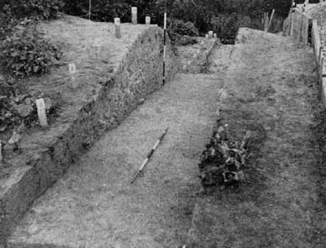
Photo Caption: Figure 3: Section cut through the defences of Fort II, looking North-West.
The east entrance is linked to a (probably ancient) trackway which runs under the eastern defences. The ramparts at this point, which were widened by the addition of outerworks, were revetted with stonework and timber. Much of the revetment is still intact (see Figure 2) and many post-holes and stake-holes show where there were also timber supports. A bridge carried over the entrance on posts, would have enabled the defenders to cross from one end of the rampart to the other. This bridge was probably combined with removable timbers which could have been used for blocking the entrance when necessary. After running through the outer rampart the roadway, which was cobbled with iron-stone nodules, crossed the ditch by means of a causeway and then entered the fort through the inner rampart, where there were gates hung on substantial posts (the post-holes have survived) and there was another timber bridge across the gap made by the entrance. The inner rampart carried a palisade and was also revetted with stonework and timber, but all this had tumbled into the ditch, where we found dozens of stones mixed with burnt posts and planks -- dramatic evidence of the fact that the fort came to a sudden end. The fort's destruction appears to have been followed by a peaceful phase during which agriculture was carried on in what was a reasonably level and well-drained area, conveniently cleared of its forest cover by the builders of the fort. The evidence for this is two drainage gullies on either side of the entrance which must have been dug not long after the burning of the fortifications.
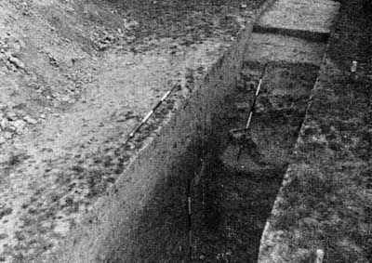
Photo Caption: Figure 4: Section through the ditch of Fort II, where the rampart has been ploughed down, looking North-East.
Fort II, which lay south-west of and followed Fort I, enclosed 2.5 acres; it commanded a view over the low ground between Castle Hill and Quarry Hill. It was defended by a V-shaped ditch 16-18 feet Wide and 6-8 feet deep, cut out of the natural rock and by a rampart made of the material dug from the ditch. The front of the rampart was held up by a revetment of wood and stone, and there was a palisade along the top. In some parts there was a low bank outside the ditch. Figure 3 shows a section through these two banks with the ditch (partly out of sight) between. The charcoal which dated the fort came from the old land surface near the ranging pole. Where the defences cross the ploughed field the rampart has been destroyed, but the ditch survives and this is shown in another section which we dug (Figure 4). A few pieces of pottery dropped by the builders came to light under the rampart, but none at all inside the fort where we dug a number of trenches.
The evidence as a whole, which admittedly comes from only selective digging suggests that neither fort was occupied for very long, and that Fort II was built after Fort I. It is important to have obtained two radiocarbon dates in the 4th and 3rd centuries BC.
Interim reports (where Forts I and II are called B and A respectively) have already appeared in Arch. Cant. See Footnote [2]

Notes:

Footnote 1.
Arch. Cant. 41 (1929), 193-5. Return to the paragraph.

Footnote 2.
Arch. Cant. 84 (1969), 2334; 85 (1970), 176-7; 86 (1971), 2334; and 87 (1972), 219. Return to the paragraph.

Close Window
Accessed this page via search engine or bookmark? Full K A R Index here.

From Exploring Kent's Past:
"Castle Hill Camp, a multi-vallate hill-fort, with an area of c.17 acres, inside the outer bank. It was excavated by S.E. Winbolt, in 1929, when flint artefacts and iron slag were found. An entrance on the east was paved and had stone-revetted sides. No evidence of permanent occupation was found the finds are in Tonbridge Public Library. (See illus 1) (2-3) The Castle Hill earthworks are situated on a spur of high round, running from NE to SW, c. 400 feet above sea-level. The natural slopes are nowhere very steep. On the SW of the spur is a kidney- shaped enclosure, with the characteristics of an IA contour fort, formed by a rampart and outer ditch. The NE side is under plough but has slight indications of a causewayed entrance. To the NE, the promontory has been cut off by a deep ditch with an outer bank and traces of an inner bank, obscured in places by a modern hedge-bank. The southern part of this earthwork has been badly mutilated and its original form is difficult to determine. An additional outer bank here may be merely part of an old approach road. The northern end of the earthwork ends abruptly for no obvious reason. A centrally placed entrance is represented by a gap in the outer bank and a probable causeway across the ditch. The true nature of this earthwork is uncertain; it does cut off the promontory but its defensive value is negated by the weak flanking slopes. There is no evidence that it was ever directly connected to the contour fort - the linking bank to the NW, identified by Winbolt, is a field boundary of no great age. It may be an unfinished work, possibly a later strengthening of the contour fort. At Tunbridge Wells Museum are flint artefacts from Castle Hill, identified as Mesolithic and BA; some are exhibited.
Castle Hill, a full excavation report of work carried out into the two separate forts on Castle Hill. Excavations were carried out in 1969, 1970 and 1971 and a watching brief in May-June 1965 during pylon construction. An interim report appeared in 1971. That there were two Hill Forts was first recorded by E. Geary, Wimbolt being misled into believing it was a single fort by the destruction of the defences in the arable field. Apart from recognising an ironstone roadway in the east entrance of Fort I the Wimbolt report is of little or no value and the finds from his excavation are now lost. Worked flints and waste material, mainly Mesolithic, and three Neolithic sherds were found but there were no concentrations to suggest occupation in these periods. Fort I, Radiocarbon dated to c.315 BC, enclosed an area of 2-9 acres. The north-eastern defences are intact and the entrance was positioned centrally on the east side. South of the entrance the earthwork has been badly mutilated. The OS map includes some features which look modern and they have been omitted from the Field Survey. The south-eastern defences have been demolished but there are definite signs on air photographs (a and b). Two trenches have been dug: site K - through to northern defences and site L - at the east entrance. What was left of the inner rampart was 12 ft wide and had a maximum height of 33 ins. Originally it was 15 ft or perhaps 18ft wide. Between the inner and outer ramparts was a steep-sided V-shaped ditch, 27 ft wide and 12 ft deep. Fort II, carbon dated to c.228BC, enclosed an area of 2.5 acres. Two-thirds of the earthwork still survives, consisting of a single bank and a ditch except in the north-west corner where there is a counter-scarp bank. The north-east defences have been demolished but it is still visible as a slight ground swelling. Excavations have taken place, sites D and F, into the north-west defences. The inner rampart was 19ft wide at the base and had survived to a maximum height of 4ft. Site E, of an excavation into the entrance suggested by Geary but work proved that no entrance existed here. It is suggested that an entrances may exist to the south-east, marked ?entrance on illus, as there are slight indications on the round. Site J was an attempt to find evidence of a causeway under the modern track. None was found."
http://extranet7.kent.gov.uk/ExploringKentsPast/SingleResult.aspx?uid=MKE1116

